Micro Design Document

**Age of Speed**

Medieval Racing Game

Collect peasants to go faster, fire projectiles at your opponents to make them lose peasants.

**What is the Game?- Ben**

Age of Speed is a simple 2D racing game set in the medieval ages in which players will be able to use siege weapons and carts as vehicles. The game will have an overhead camera to allow the players the best field of view possible in a 2D racing game. An example of a game that puts good use to this camera setup is the original *Grand Theft Auto* game. There will also be a combat option during the race if the player has the right vehicle and the ammunition. This will allow the player to make use of the siege weapons in the game if they wish. Below is an image of “*Grand Theft Auto 2”* which shows a good example of the camera angle that will be used in *Age of Speed.*

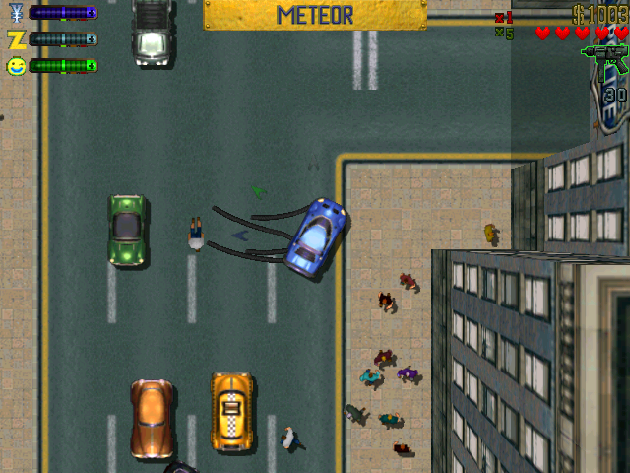

**Gameplay - Ben**

The player will get to pick out a vehicle that they want to race with. Each vehicle that the player can choose will have a different weight and a different projectile that they fire, if any. The higher the weight the larger the weapon. The race will start and each racer will have a peasant pulling their chosen vehicle which will have a different speed based on the weight of the vehicle chosen. The racers can choose to either collect more peasants to increase their speed or steal them from other racers by firing projectiles at the racer in front of them. The ammunition for the players weapon can also be found on the track and fired towards other racers. If a racer is hit with a projectile they will lose half of their peasants, leaving them on the track for the racers behind to collect.

The four vehicles that will be available will each have different stats that will make them more useful in certain situations than others. The vehicles and a summary of their difference are listed below: (Not Final)

* Trebuchet - An extremely heavy vehicle that can hurl large projectiles a great distance
  + Pros -
    - Can throw larger projectiles greater distances.
    - Can take corners slightly better due to low speed and greater weight.
    - Collisions will remove less peasants.
  + Cons -
    - Larger target making it easier to hit.
    - Slower movement.
    - Slower projectiles
* Ballista - The Lightest siege vehicle available, making it faster than the rest.
  + Pros -
    - Very light and fast.
    - Small Target making it harder to hit.
    - Projectiles move faster
  + Cons -
    - Smaller projectiles
    - Takes more damage than other siege weapons
* Catapult - A mix between the Ballista and the Trebuchet
  + Pros -
    - A good mix between weight and speed.
    - Medium sized projectiles move at a decent speed.
  + Cons -
    - Neither the fastest nor the best protected
* Cart - An unarmed vehicle.
  + Pros -
    - Extremely light and fast.
    - Smallest vehicle with good maneuverability.
  + Cons -
    - Has no offensive weapons.
    - Collisions with projectiles will remove most peasants.

The game will also have a few different tracks available for the players to choose from which would include a Castle, a Market place, and a Farm. The castle track will have tighter corners while the farm will have more straight lines in the track. The market will be a mixture of tight corners and straight lines.

**Basic Artwork - Andrew**

|  |  |
| --- | --- |
| Description | Concept sketch |
| Player Vehicle: Trebuchet | Aos_Treb2.png |
| Player Vehicle: Ballista | AoS_Bal.png |
| Player Vehicle: Catapult | Catap_01.png |
| Player Vehicle: Cart | cart_01.png |
| Pick-up: Peasant | AoS_Pes.png |
|  |  |

**Controls - Andrew**

Keyboard Control Scheme:

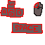

w - Accelerate

s - Brake

a/d - turn left/right

space/left click - shoot